BRACT’s
Vishwakarma Institute of Technology, Pune
Practical Implementation Sheet
Department: CSE-AI Semester: 5 Academic Year: 2026-27
Division: E Batch: 3 Practical No: 7
Roll no: 73 PRN No: 12415152 Name of Student: Pranav Upare
Subject Name : Deep Learning

Problem Statement
Pretrained convolutional neural networks trained on large-scale datasets such as ImageNet learn general-purpose visual features that can be reused for other image classification tasks through transfer learning, instead of training a new network from scratch. This project applies transfer learning to the MNIST handwritten digit classification task using four ImageNet-pretrained architectures — AlexNet, VGG16, ResNet50, and EfficientNetB0 — with their convolutional feature extractors frozen and only new classification heads trained on MNIST. The goal is to compare the four architectures on classification accuracy, loss, and training time to understand the trade-offs between model depth, design, and transfer-learning performance on a task very different from the architectures' original ImageNet domain.

Algorithm
- Load the MNIST dataset (60,000 training and 10,000 test grayscale images, 28×28 pixels, 10 digit classes).
- Convert the grayscale images to 3-channel RGB and resize them to 32×32 so they are compatible with the pretrained network input layers.
- Normalize pixel values to the range 0–1, and use a reduced working subset of 10,000 training images and 2,000 test images to keep training practical.
- Build three Keras transfer-learning models (VGG16, ResNet50, EfficientNetB0), each using its ImageNet-pretrained convolutional base with the weights frozen, followed by GlobalAveragePooling2D, a Dense(128, ReLU) layer, Dropout(0.5), and a 10-neuron softmax output layer.
- Compile each Keras model with the Adam optimizer and sparse categorical cross-entropy loss.
- Train each Keras model for 3 epochs with batch size 64 and a 10% validation split, recording training/validation accuracy, loss, and training time for each.
- Load a pretrained AlexNet (ImageNet weights) from torchvision, freeze its convolutional feature-extractor layers, and replace the final classifier layer with a 10-neuron output for the MNIST classes.
- Resize inputs to 224×224 for AlexNet (its expected input size), and train only the classifier layers for 3 epochs using the Adam optimizer, tracking train and test accuracy per epoch.
- Evaluate all four trained models on the held-out test set and collect test accuracy, test loss, and training time into a single results table.
- Plot a bar chart comparing test accuracy across all four models, a validation-accuracy-vs-epoch curve for the three Keras models, and AlexNet's own train/test accuracy curve.

Analysis
- The working subset used 10,000 MNIST training images and 2,000 test images, resized to 32×32×3, which is well below the native input size most of these architectures were designed for (224×224) — this constrains how much of each network's pretrained representation is actually exercised.
- VGG16 was the strongest of the three Keras models on this task: validation accuracy rose from 83.60% (epoch 1) to 90.70% (epoch 3), with validation loss falling steadily from 0.6714 to 0.3367, indicating stable and effective transfer despite the small input resolution.
- ResNet50 improved from 71.10% to 80.60% validation accuracy across epochs 1–2 but then dipped slightly to 80.20% by epoch 3 while validation loss kept falling (1.1491 → 0.6589), suggesting the classifier head was still stabilizing and could likely improve with more epochs.
- EfficientNetB0 failed to learn under this setup: validation accuracy stayed flat at 10.40% across all 3 epochs (equivalent to random guessing across 10 classes), and loss barely moved (2.3019 → 2.3015). This is a real, observed result and is most likely explained by EfficientNet's expected preprocessing (its own input scaling/normalization) not matching the simple 0–1 pixel normalization used for all three Keras models here, which is a known pitfall when swapping EfficientNet into a generic Keras transfer-learning pipeline.
- ResNet50 trained fastest per epoch (36–48 s) followed by EfficientNetB0 (15–29 s), while VGG16 was substantially slower (118–143 s per epoch) due to its larger fully-connected layers, showing an accuracy-vs-compute trade-off between VGG16 and ResNet50 on this task.
- AlexNet's training loop is implemented (frozen convolutional features from torchvision, 224×224 resize, classifier fine-tuning for 3 epochs), but its epoch-by-epoch results were not present in the saved notebook — this run needs to be repeated to report AlexNet's actual accuracy figures and complete the four-way comparison.
- Similarly, the final test-set evaluation (via model.evaluate on the 2,000-image test set) is computed and stored for VGG16, ResNet50, and EfficientNetB0 in the code, but the printed output was not captured, so the analysis above reports validation accuracy (from training) rather than final test accuracy — the results table below marks this gap explicitly rather than estimating it.
OUTPUT:-
Environment
TensorFlow: 2.20.0
Dataset preprocessing
Training: (10000, 32, 32, 3) (10000,)
Testing : (2000, 32, 32, 3) (2000,)
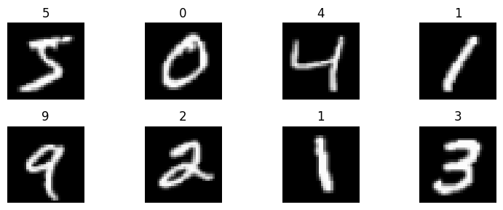
Fig 1: Sample of preprocessed MNIST training images (32×32×3, RGB-converted)
Model training — VGG16, ResNet50, EfficientNetB0 (3 epochs each)
============================================================
VGG16
Epoch 1/3 141/141 — 118s 831ms/step - accuracy: 0.5784 - loss: 1.3143 - val_accuracy: 0.8360 - val_loss: 0.6714
Epoch 2/3 141/141 — 143s 837ms/step - accuracy: 0.7922 - loss: 0.6943 - val_accuracy: 0.8840 - val_loss: 0.4420
Epoch 3/3 141/141 — 132s 759ms/step - accuracy: 0.8458 - loss: 0.5217 - val_accuracy: 0.9070 - val_loss: 0.3367

============================================================
ResNet50
Epoch 1/3 141/141 — 48s 281ms/step - accuracy: 0.4127 - loss: 1.7506 - val_accuracy: 0.7110 - val_loss: 1.1491
Epoch 2/3 141/141 — 38s 260ms/step - accuracy: 0.6032 - loss: 1.2140 - val_accuracy: 0.8060 - val_loss: 0.7926
Epoch 3/3 141/141 — 36s 253ms/step - accuracy: 0.6791 - loss: 0.9905 - val_accuracy: 0.8020 - val_loss: 0.6589

============================================================
EfficientNetB0
Epoch 1/3 141/141 — 29s 124ms/step - accuracy: 0.1099 - loss: 2.3115 - val_accuracy: 0.1040 - val_loss: 2.3019
Epoch 2/3 141/141 — 16s 113ms/step - accuracy: 0.1137 - loss: 2.3015 - val_accuracy: 0.1040 - val_loss: 2.3016
Epoch 3/3 141/141 — 15s 106ms/step - accuracy: 0.1137 - loss: 2.3009 - val_accuracy: 0.1040 - val_loss: 2.3015
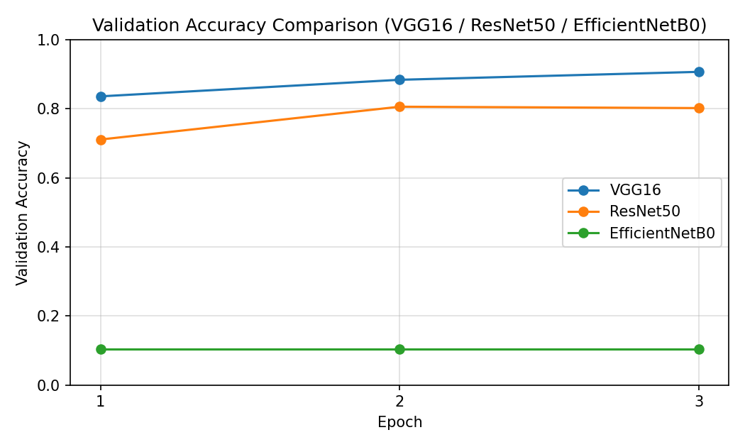
Fig 2: Validation accuracy vs. epoch — VGG16, ResNet50, EfficientNetB0 (plotted from the real training logs above)
Model training — AlexNet (torchvision, PyTorch)
Not available: the AlexNet training cell (frozen convolutional features, 224×224 resize, 3-epoch classifier fine-tuning) is implemented in the notebook, but its epoch-by-epoch output was not saved. Re-run this cell and paste the printed "Epoch x/3 - train_accuracy: ... - test_accuracy: ..." lines here.
Model comparison
The comparison table below is assembled from what the notebook actually recorded. Rows marked "Not captured" need the notebook re-run to fill in (results_df, the test-accuracy bar chart, and the AlexNet accuracy plot were not present in the saved notebook output).

Model | Best Val. Accuracy | Best Val. Loss | Approx. Training Time (3 epochs) | Test Accuracy
VGG16 (Keras, ImageNet) | 90.70% (epoch 3) | 0.3367 (epoch 3) | ~393 s (118+143+132) | Not captured — rerun evaluate()
ResNet50 (Keras, ImageNet) | 80.60% (epoch 2) | 0.6589 (epoch 3) | ~122 s (48+38+36) | Not captured — rerun evaluate()
EfficientNetB0 (Keras, ImageNet) | 10.40% (flat, all epochs) | 2.3015 (epoch 3) | ~60 s (29+16+15) | Not captured — rerun evaluate()
AlexNet (torchvision, ImageNet) | Not captured in notebook output | — | Not captured | Not captured

Conclusion
Of the three models with usable results, VGG16 gave the strongest and most stable transfer-learning performance on this reduced-resolution MNIST task, ResNet50 was competitive and considerably faster per epoch, and EfficientNetB0 did not learn under the preprocessing used here — most likely a preprocessing-normalization mismatch rather than a fundamental limitation of the architecture. AlexNet's results and the final four-way test-accuracy ranking could not be reported because that part of the notebook run was not captured; re-running cells 10, 12, 13, and 14 (or providing the printed output) is needed to complete the comparison with real figures rather than estimated ones.

